
Regulatory Binder Guidelines

Food and Drug Administration (FDA) regulations (21 CFR 312.62; 21 CFR 812.140) state that the investigator must keep records relating to disposition of study drug/devices, including dates, quantity and use by study subjects; case histories including case report forms, consent documents and supporting information and observations (source docs); and correspondence with IRB, sponsors and monitors.
ICH GCP Guidelines define essential documents as those documents which individually and collectively permit evaluation of the conduct of a trial and the quality of data produced. These documents serve to demonstrate compliance with standards of Good Clinical Practice and with all applicable regulatory requirements.
Essential documents (aside from subject-specific case history documentation kept in individual subject files) are most often assembled in what is referred to as the regulatory binder. The regulatory binder is referred to synonymously as the study files, investigator files or investigator binder. Not all documents have to be filed in one single binder. The regulatory binder may sometimes consist of several binders that are stored in the same or different locations. It is important to know where all of the documents are located to access them when needed in a timely manner; the regulatory binder is often the first document reviewed during audits and inspections.
Filing essential documents in a timely manner can greatly assist in the successful management of a clinical trial or research project. Not all the essential documents are available at the start of the study. Documents can be grouped into those that are generated before study initiation, those that are generated during trial conduct and those that are generated after study completion.
Conducting research involves data collection that must be accurately maintained and properly documented. At Texas Christian University, researchers must keep a current binder for data and record keeping purposes, as common practice. This is commonly referred to as the Regulatory Binder (other names include Investigator Binder, Study Binder, and so on) which can be either electronic documentation, hardcopies or a combination of both.
Note that while this guidance was specifically designed with clinical research in mind, general components can certainly aid in the organization of study information for any type of research; thus, all researchers are welcome to use this model.

Creating Your Regulatory Binder
The following tabs are recommended for use in the regulatory binder. This document serves as a template and may be modified for study-specific requirements. Documents should be filed in reverse chronological order. It is the responsibility of the investigator to ensure compliance with GCP and applicable regulatory requirements.

1. Organizing Your Regulatory Binder

Instructions: Create tabs for each applicable section listed below and place the appropriate documents in each corresponding section in a binder. Be sure to label the outside of the binder (cover and spine) with the protocol number, PI name, and study site. Or if storing study document in the TCU Box label the main study folder with the same variables in the previous sentence. Use multiple binders, master binders, or create as many folders within the Box to maintain documentation if needed.

Sections marked with an asterisk have associated example forms kept on the HRPP website. These example forms are not required to be used but do show recommended content.

All sections are strongly recommended unless otherwise indicated.

A. Delegation of Authority (Responsibilities) Log*
This log documents responsibility assigned to research team members and their dates of involvement in the project. It helps to ensure the appropriate delegation of study related tasks and it should usually be consistent with the research team section of the IRB Application.

B. Site Personnel Signature Log*
This documents the names and provides handwriting samples of all personnel involved in the conduct of the study. This log is helpful for auditors and monitors to quickly determine which member of the research team performed various duties throughout the life of the study.

C. Study Personnel Education
Required institutional training documentation can be kept in this tab. All personnel involved in research with human subjects are required to complete the following:

- CITI Course Human Subjects Researcher (Biomedical or Social-behavioral-educational)
- HIPAA Training (as applicable to your study)
- CITI Conflict of Interest Training
- An optional but recommended course: CITI Good Clinical Practice (GCP).

When adding personnel to the study, personnel must complete all of the above and their addition to the protocol must be IRB approved prior to participating in the study.

D. Training Log*
This is a record of protocol specific training, e.g. protocol training or other study-specific training of staff.

E. CVs/Conflicts of Interest
This section should include the Curriculum Vitae (signed & dated) for all investigators and site staff professional licensure (including DEA if applicable). Any Conflict of Interest disclosures should also be kept in this section. Please see the Office of Sponsored Programs website for details.

Note: Anytime information is kept in a master binder, place a note to file (in the section of the Binder) referencing the location of the separate binder and/or make sure all supplemental binders are provided to auditors/monitors to avoid unnecessary findings.

F. Eligibility Criteria Checklist*
This section should include a checklist for each subject screened that shows that each inclusion criterion to be in the study is met and the supporting documentation (or reference the location of source documentation).

G. Screening/Enrollment Log*
This section should include a log of subjects who were screened (and reason for screen failure) and enrolled. Some studies allow for re-screening of subjects.

H. Subject Visit Tracking Log*
This log tracks all enrolled subjects' visits, reason for early termination and keeps visits scheduled as per protocol.

I. Subject Identification Code List*
This is a confidential list of the names of all the subjects that provides a link between their identity and their study code to allow the Investigator to reveal the identity of any subject, if necessary.

J. Consent/Assent/HIPAA Authorization Forms (consent materials)
This section should include a log to track versions of consent materials and when they were submitted to and approved by the IRB. All consent materials should be kept with IRB approved and stamped versions stored in reverse chronological order with the current approved versions placed first (See L (below) for where to download stamp consent/assent forms). Place most currently approved consent materials in a plastic sleeve or develop a similar system that clearly establishes the current versions for use.

There should also be a listing of subjects showing the date the current version of the consent is signed. (See above Screening/Enrollment Log)

Note: Any changes to the consent materials must be submitted to and approved by the IRB prior to use.

K. Sponsor Protocol, TCU Application, Grant and/or Scope of Work
This section should include the sponsor’s protocol, TCU application, grant, and/or scope of work and all amendments/modifications stored in reverse chronological order with the current approved version first.
Note: Any changes to the protocol must be submitted to and approved by the IRB prior to implementation.

L. IRB Approval(s) /Communication
This section should include copies of the original IRB application/submission, IRB approval letters (contingent and final approval), and all correspondence with the IRB (including relevant emails). It includes continuation/annual check-in review submissions, protocol modifications, incidents and DSMB reports and close-out (final study) reports.

Note: All IRB-Approved stamped documents are available in the attachments tab of each initial and modification submission.

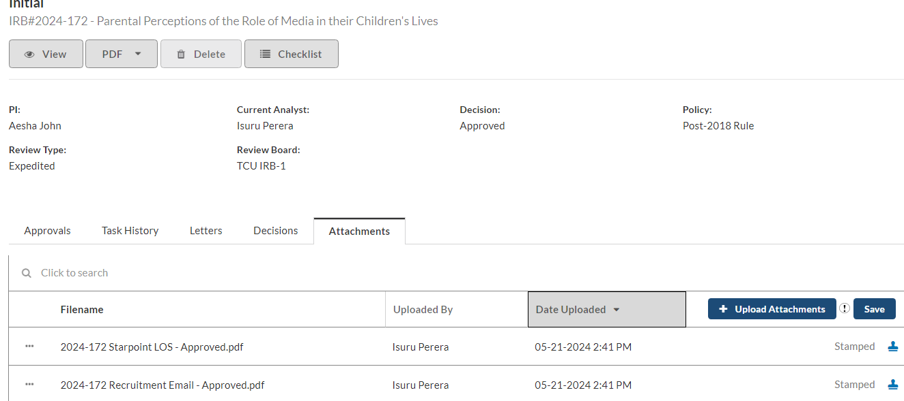

M. Sponsor Approval(s) /Communication
This section should include copies of correspondence with the study sponsor/CRO.

N. Investigational Product Information (as applicable)

Investigator's Brochure (IB)
This section must include all versions of the IB (may be maintained separately with note in
section explaining location of IB) and receipt forms.

Evidence of IRB submission and review of all versions must be maintained.

Package Insert
For FDA approved agents, file a copy of the package insert.

Device Manual
For device studies this section should have a device information sheet/manual.

O. Study Termination/Closure
If your research study is being closed/terminated or if the PI is leaving and the study will no longer be continued, a Final Report (Study Closure Submission) should be submitted in Cayuse
and related documentation and correspondence kept in this section.

P. Protocol Deviations/Protocol Violations
This section should include correspondence relevant to the issue/events and copies of the documents stored in reverse chronological order with the most current documents first. The section can also include IRB and sponsor requirements/guidelines for reporting.

Q. Serious Adverse Events
This section should include correspondence, copies and acknowledgements of reports for internal SAEs reported to the IRB and Sponsor and FDA as applicable. The section can also include IRB and sponsor requirements/guidelines for SAE reporting.

R. Advertising/Educational Materials (if applicable)
This section should include: any IRB approved advertisements, recruitment flyers, written educational, or other materials provided to study participants, stored in reverse chronological order with the most current documents first.
Only stamped IRB-approved recruitment materials should be used.

S. Lab Certifications/Documents
This section should include any information related to lab certifications, normal ranges, etc.
Contact details (name, address, etc.), CLIA (clinical laboratory improvement amendments)
/CAP (college of American pathologist) certifications, Procedures for Sampling, Labelling,
Storing and Shipping, and Temperature Logs.

T. Drug/Device Accountability Log
This section should include a log of dispensation of study drugs/devices, including dates, quantities, returned product, etc.

U. Other Documents
Place other important study documents in this section. This can include: certificates of confidentiality, literature or publications, correspondence from the FDA, NIH, etc., Cayuse application, Cayuse approval letter, any relevant ancillary committee approval letter (IBC), other compliance approvals, FDA Form 1572, IND app/approval, and other general correspondence.

Note: If any work with a non-TCU facility or agency is being done or your study includes any clinical procedures, a determination of the need of collaboration agreement or other legal type of agreement may be needed. Contact the Office of Research Compliance.

Best Practice Recommendation:

• Store items in reverse chronological order, with the newest items within a section placed at
the front of the section.
• Use the requirements note at the top of each binder tab to determine if that section is required
for your study.
• Multisite studies: The lead site may choose to customize the binder tabs for the study and
provide to all participating sites.
• Electronic documents: The recommendation is to store paper copies of documents in the
binder. However, if you elect to use only electronic copies of particular documents, the
following guidelines should be observed:

o Either a) place a paper placeholder in the relevant location of the binder that directs an individual to the electronic location OR
o b) place a paper placeholder in one location in the binder that includes a list of all documents that are stored only in electronic format, along with the specific electronic path for each item.

• Electronic-only documents should be limited to documents that a) are easily accessible by site
staff; b) an inspector, auditor, or clinical monitor can be provided with easy access to the
relevant electronic materials during a site visit; and c) the electronic location is controlled,
regularly backed up, and is not in danger of disappearing or changing in the foreseeable
future.

• For e-mail correspondence, sites may want to include clarification in the binder that e-mail
will be archived to a permanent storage medium on a particular schedule (specify in
documentation) and the media will be stored in the binder or an easily accessible location.

References:
Georgetown University
Emory University
Children’s Hospital Boston

